**University of Michigan – Dearborn**

**CIS 200 – Computer Science II**

**Lab# 5**

**Professor Robert Mann**

Demetrius Johnson

[meech@umich.edu](mailto:meech@umich.edu)

October 13, 2020

**Table Content**

Contents

Task 1 DELIVERABLES 3

Task 2 – unable to complete using the GUI interface as it would not work even after much consultation with Professor and Lab Professor; so I had to do it in PUTTY CLI… 4

Task 3 DELIVERABLES 5

Task 4 DELIVERABLES 6

Task 5 DELIVERABLES 7

# Task 1 DELIVERABLES

- You should capture a snippet of the output after both step 3 and step 4 and paste it into your Word document.

Step 3 & 4 Screenshot:

***screenshot showing the login and printing the current directory and creating cis200 directory:

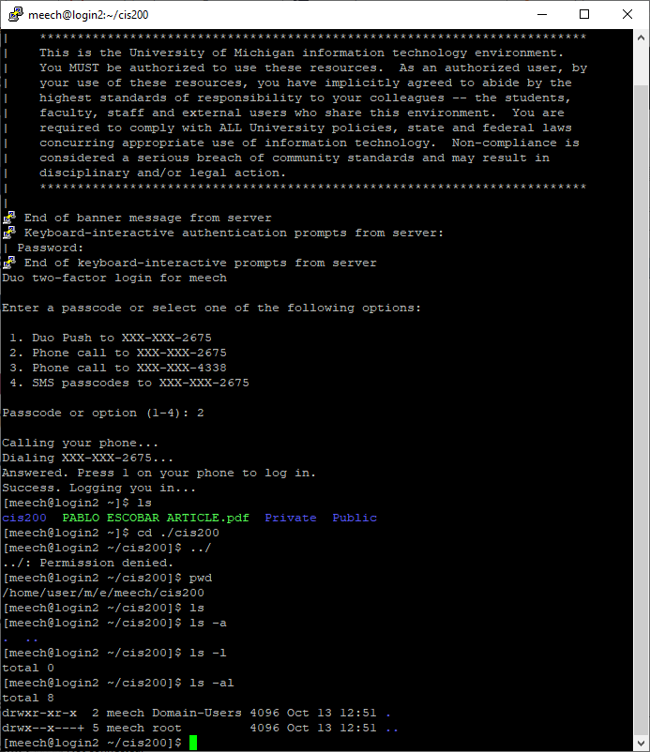

# Task 2 – unable to complete using the GUI interface as it would not work even after much consultation with Professor and Lab Professor; so I had to do it in PUTTY CLI…

***g++ compile hello.cpp and executing the output file “hello”:

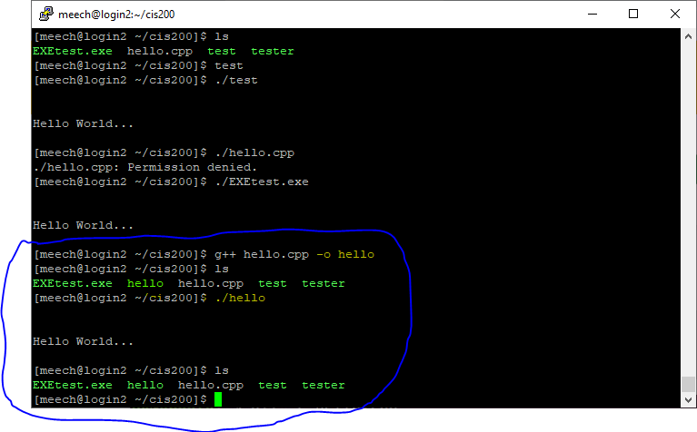

# Task 3 DELIVERABLES

***Screenshot showing the use of vim to create and write the file hello2.cpp:

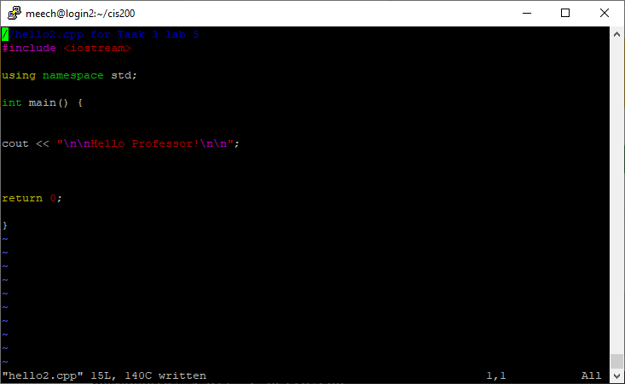

***compiling via g++ hello2.cpp file and writing it to/executing the executable filename hello2:

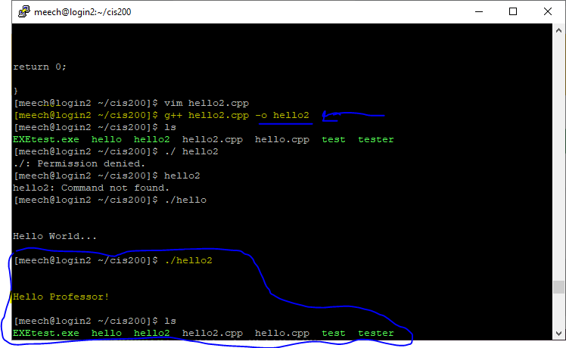

# Task 4 DELIVERABLES

***Change name of hello2 executable file to name it hello_prof; then execute hello_prof program:

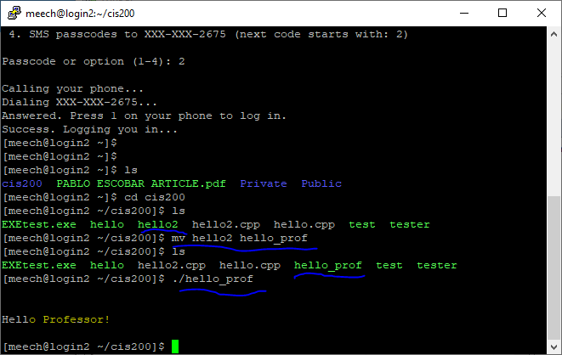

# Task 5 DELIVERABLES

***screenshot showing current directory is cis200 and that contents it contains is only subdirectory lab5assg (also shows the remove and copy commands issued):

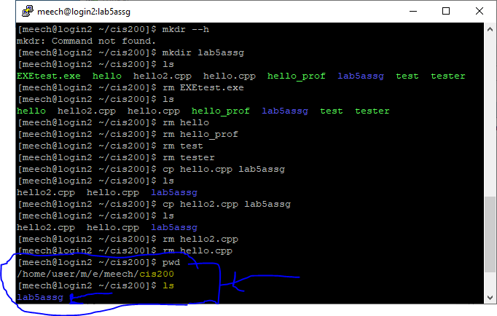

***screenshot showing current directory is lab5assg (cis200 subdirectory) and contains only the copied .cpp cource files; also shows the remove and copy commands just as previous screenshot:

